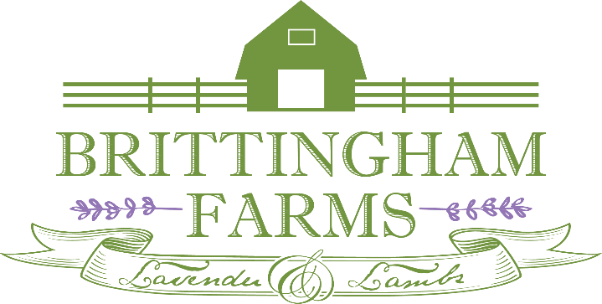

Brittingham Farms Volunteer Application
Please send completed application to Brittingham Farms at brittinghamfarms@yahoo.com or 22518 Phillips Hill Road, Millsboro, DE 19966. We will reach out to you directly and/or add you to our Volunteer Email List for further opportunities.
Contact Information
Name:___________________________________________________________________
Address:_________________________________________________________________
City:__________________ State: ________ Zip: _________________
Phone:___________________________ Email: __________________________________
I am a student volunteer under the age of 18 Yes or No

Emergency/Guardian Contact Information
Emergency Contact Person:____________________________________________
Relationship to you:_______________________ Phone: _____________________
Do you have any allergies or physical ailments we should be aware of in case of an emergency?_________________________________________________________

Tell Us More
What do you want to get out of your volunteer experience at Brittingham Farms LLC? _______________________________________________________________________________________________________________________________________________________________________________________________________________________________________

Brittingham Farms Volunteer Application, Page 2
Interests/Hobbies:___________________________________________________________________________________________________________________________________________
Previous Volunteer Experience:___________________________________________________
Employment Status: (Circle) Full Time Part Time Retired Student Other:______________
Professional Skills:______________________________________________________________
Days/Times you are interested in Volunteering at Brittingham Farms: _______________________________________________________________________________________________________________________________________________________________________________________________________________________________________
Circle any areas you are interested in Volunteering:
Harvesting of Lavender Livestock Greenhouse Work Weeding/Watering

Greeter Special Events Possible Employment Distilling Lamb Socialization

Parent/Guardian Release for Volunteers under the Age of 18
I am the parent/guardian of the minor volunteer and on behalf of myself, the minor participant, and all other parents or guardians of the minor volunteer, I (i) understand that I am responsible for all acts committed by my minor child while on Brittingham Farms grounds, (ii) authorize any medical care that may be necessary to the minor volunteer, and (iii) authorize my minor child to volunteer at Brittingham Farms LLC
Name of Parent/Guardian:__________________________________________________________________________
Signature of Parent/Guardian:_________________________________________ Date:_________________________
Agreement and Signature
By submitting this application, I affirm that the facts set forth in it are true and complete. I understand that if I am accepted as a volunteer, any false statements, omissions, or other misrepresentations made by me on this application may result in immediate dismissal.
Thank you for your interest in Brittingham Farms LLC, we look forward to working with you!
Signature:_______________________________________________________________________________________
Name (Printed):___________________________________________________ Date:___________________________
Office Use Only: Cold/Warm Contact ______________ Interview:________________ Orientation:Basic/Livestock/Lavender:_____________________
Notes:___________________________________________________________________________________________________________________________________________________________________________________________

Brittingham Farms Volunteer Application, Page 3
Volunteer Assumption of Risk and Release of All Claims

Thank you for volunteering at our farm! We appreciate that you have chosen to spend time with us. Before you begin, we need you to know that volunteering on our farm can expose you to personal injury or damage to your property. This waiver outlines our respective rights and responsibilities relating to that risk. Please read this waiver carefully and let us know if you have any questions.

- Volunteer Status
I would like to volunteer in activities at Brittingham Farms, LLC. I understand that as a volunteer I will not be paid for my efforts and I will not be covered under workers compensation insurance. I am at least 18 year so age and I will get consent of the Farm to bring anyone younger than 18 to the Farm.

- Risks of Volunteering
I understand that the activities at the Farm involve serious risk. I may be exposed to, for example, but not limited to: insects; wildlife; farm animals; inclement weather; extreme temperatures; heavy machinery; tools; the actions and negligence of employees, volunteers, and other people present on the farm; and dangerous conditions on the land such as holes in the ground or barbed wire. I understand that these examples are not all-inclusive and there may be additional risks, all of which may involve serious personal injury, death or damage to my property.

- Release of Claims and Assumption of Risk
In exchange for the opportunity to participate in activities on the Farm, I (and my family, heirs, and personal representatives) willingly and knowingly release the Farm and its officers, owners, employees and agents from any and all liability for any personal injury or damage relating to my participation. I (and my family, heirs, and personal representatives) agree to assume all of the risks and responsibilities of my participation. I understand that I am solely responsible for any hospital or other costs arising out of any personal injury or property damage relating to my participation on the Farm.

- Medical Care Authorization
I am physically fit to participate in activities on the Farm. I understand that there are no medical services available on site or otherwise, and I give permission to the Farm to authorize emergency medical treatment for me. I release the Farm and its officers, owners, employees and agents, from liability for any injury or damage that might extend from such emergency medical treatment.

I further agree that this waiver should be interpreted as broadly and inclusively as state law permits.

Printed Name of Volunteer

Signature of Volunteer

Date

